Tuesday-Friday
2022-2023
Helena Middle School
6th Grade
Period 1 | 8:05 | 8:56
Period 2 | 9:00 | 9:51
Period 3 | 9:55 | 10:49
Lunch | 10:49 | 11:09 | Lunch
Recess | 11:09 | 11:29 | Recess
Period 4 | 11:33 | 12:24
Period 5 | 12:28 | 1:19
Period 6 | 1:23 | 2:14
Period 7 | 2:18 | 2:50 | Advisor

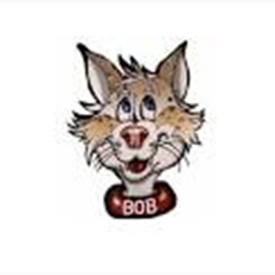
Tuesday-Friday
2022-2023
Helena Middle School
7th & 8th Grade
Period 1 | 8:05 | 8:56
Period 2 | 9:00 | 9:51
Period 3 | 9:55 | 10:49
Period 4 | 10:53 | 11:44
Lunch 7th grade | 11:44 | 12:04 | Recess 8th grade
Lunch 8th grade | 12:04 | 12:24 | Recess 7th grade
Period 5 | 12:28 | 1:19
Period 6 | 1:23 | 2:14
Period 7 | 2:18 | 2:50 | Advisor

