Family Night @ the HMS Library
Cultural Exploration of Peru

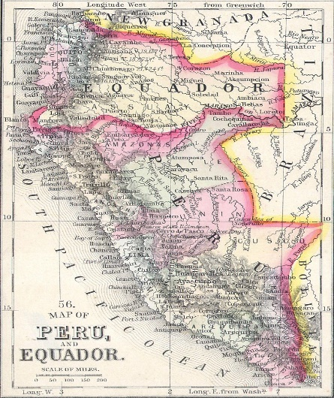
This Photo by Unknown Author is licensed under CC BY-SA

Language: https://www.youtube.com/watch?v=ZzODcMbFb8E

Literature: Books in HMS Library
- Peru by Laurel Corona
- Peru: The People and Culture by Bobbie Kalman
- Machu Picchu by Gillian Richardson
- The Inca City of Cusco by Nicholas Saunders
- Machu Picchu: City in the Clouds
- Peru in pictures Herón Márquez
- Lost in the Amazon: A battle for Survival in the Heart of the Rainforest (true story of young girl who was the only survivor of a plane crash).

Peru travel site: Great online resource: https://www.peru.travel/en

Recipes: https://www.allrecipes.com/recipes/2433/world-cuisine/latin-american/south-american/peruvian/

